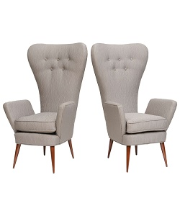

Index chair

$35.57

Availability: In stock

Description

Inspiring modern Cream Wooden High Back club Chair. Wood pointed legs, made with strong wood. Soft fabric with quality design long back support arms to rest out. Non-Assembly required.